**DAILY ASSESSMENT FORMAT**

|  |  |  |  |
| --- | --- | --- | --- |
| **Date:** | **19-05-2020** | **Name:** | **Kavyashree m** |
| **Course:** | **TCS iON** | **USN:** | **4al15ec036** |
| **Topic:** | **GAIN GUIDANCE FROM CARRIER GURUS** | **Semester & Section:** | **8th A** |
| **Github Repository:** | **kavya** |  |  |

|  |  |  |  |
| --- | --- | --- | --- |
| **FORENOON SESSION DETAILS** | | | |
| **Image of session**    **GAIN GUIDANCE FROM CARRIER GURUS** | | | |
| * **Why do u need a Head start?** * Intense competition * Talent acquisition * Employable skills * Changing job rules * Employment outlook-positive * **6 Key Pillars to get a Head start** * Clarity of thought –set a clear goal with clear milestone * Access and Visibility- means or options should exist or be created within given constants to path visibility * Early Preparation- Baseline your current skill,plan and actively work accordingly. * Acquire relevant skills- build competency and skills through training .Community learning with certification. * Compelling resume- simple and concise –provide facts,verified abilities coupled with right aptitude and relevant skills * Cracking the interview- present yourself well. Correlate your strength to company needs and show how your studio work justify same. * **Pillar 1- clarity of thoughts** * Passion in life? What really drives you ? * Excited to work for corporates ? * What should be your dream corporate /first corporate to join? * How can you contribrute to a corporate to join? * 2-5 year plan : what is your immediate/short term plans ?which route you want to tread? * Are you a right fit corporate ? do you fit into corporate culture well ? * **Pillar 2-getting visibility and access** * Job portals * Professional networking sites * Common assessment platform * Community of practise * Jobs fairs and networking      * **TCS qualifier** * HYPO database * Candidate profiling * Domain validation * Right fit * Effort to hire * Pillar 3-early preparation * Company research * Online prep test * Get expert help * Focus on communication * **Pillar 4- Acquiring industry relevant skills** * Map your interest with job roles/opportunities * Partner with digital job platform * Connect with the learning and technical forums identify the best certification in your area * Get professional training help based on your proficiency * **Pillar5- best practises on creating a winning resume** * 1-2pages resume * Simple and standard design * Dos and don’ts * Cover key details      * **Pilar 6- preparing for an interview –key factors** * Research about the company * Prepare for obvious * Practice hard * Organized and plan ahead   **Prepare a strong resume and the cover letter**   * **Objectives** * Create your own resume * Explain dos and don’ts of resume writing * Draft a well-worded cover letter * **Importance of a resume** * Resume has the power to get you an interview for your dream job * The very same resume can be the reason for your dream job just remaining a dream * Organizations use the resume to shortlist potential candidates * It is the virtual YOU**.** * **Categories of resume** * Chronological resume * Functional resume * Combinational resume * **Importance of a cover letter** * **Cover letter**     **Stay ahead in group discussion**   * **Group discussion**   It is a part of the interview process and has specific purpose.   * **Contents** * Introduction to group discussion * Format of a group discussion * Dos and don’ts * Mock group discussion * Case study of the mock group discussion * **Why is a group discussion conducted?**   To check your interpersonal skills, such as:   * Communication skills * Ability to work in a team * Listening skills * Ability to handle criticism * Knowledge of the subject * Overall personality * **Points to remember in group discussion** * Clarity * Body language * Listening * Tone of voice * Appropriate language * Courtesy * Confidenc   **AFTERNOON SESSION DETAILS** | | | |
| **Date:** | **19-05-2020** | **Name:** | **Kavyashree m** |
| **Course:** | **TCS iON** | **USN:** | **4al15ec036** |
| **Topic:** | **Python programming** | **Semester & Section:** | **8th A** |
| **Github Repository:** | **kavya** |  |  |

**Image of session**

**AFTERNOON SESSION DETAILS**

**Image of session**

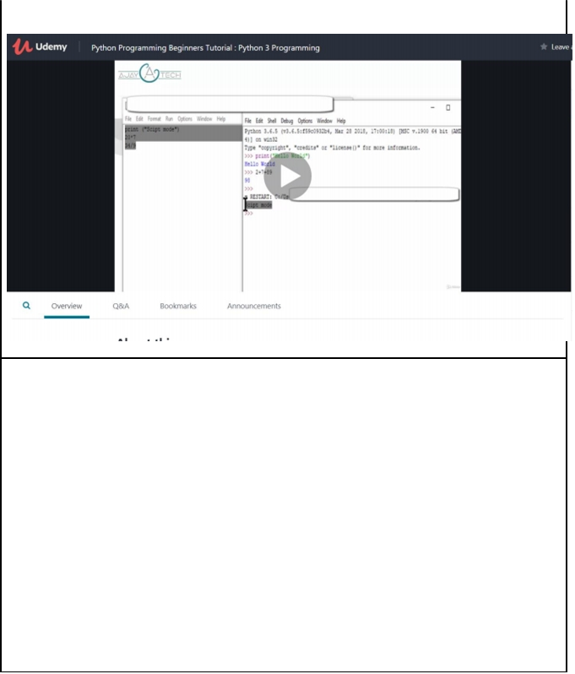

**Getting started with Anaconda:**

* Anaconda Individual Edition contains conda and Anaconda Navigator, as well as Python and hundreds of scientific packages. When you installed Anaconda, you installed all these too.
* Conda works on your command line interface such as Anaconda Prompt on Windows and terminal on macOS and Linux.
* Navigator is a desktop graphical user interface that allows you to launch applications and easily manage conda packages, environments, and channels without using command-line commands.

**Python 3.0:**

* Python 2 made code development process easier than earlier versions. It implemented technical details of Python Enhancement Proposal (PEP). Python 2.7 (last version in 2.x ) is no longer under development and in 2020 will be discontinued.
* On December 2008, Python released version 3.0. This version was mainly released to fix problems which exist in Python 2. The nature of these change is such that Python 3 was incompatible with Python 2. It is backward incompatible Some features of Python 3 have been backported to Python 2.x versions to make the migration process easy in Python 3.
* As a result, for any organization who was using Python 2.x version, migrating their project to 3.x needed lots of changes. These changes not only relate to projects and applications but also all the libraries that form part of the Python ecosystem.

**prime reasons for using Python 3.x versions:**

* Python 3 supports modern techniques like AI, machine learning, and data science Python 3 is supported by a large Python developer's community. Getting support is easy. Its easier to learn Python language compared to earlier versions.
* Offers Powerful toolkit and libraries
* Mixable with other languages

When it comes to Python version 2 vs. 3 today, Python 3 is the outright winner. That's because Python 2 won't be available after 2020. Mass Python 3 adoption is the clear direction of the future.

After considering declining support for Python 2 programming language and added benefits from upgrades to Python 3, it is always advisable for a new developer to select Python version 3. However, if a job demands Python 2 capabilities, that would be an only compelling reason to use this version.

**KEY DIFFERENCE:**

* Python 3 syntax is simpler and easily understandable whereas Python 2 syntax is comparatively difficult to understand.
* Python 3 default storing of strings is Unicode whereas Python 2 stores need to define Unicode string value with "u."
* Python 3 value of variables never changes whereas in Python 2 value of the global variable will be changed while using it inside for-loop.

|  |  |  |  |
| --- | --- | --- | --- |
|  |  |  |  |
|  |  |  |  |